# Question 3.4

## Code

clc

clear all

x=[15:10:65]

y= (4 *sind (x) + 6 ) ./ (cosd(x).^2 + sind(x)).^2

## Output

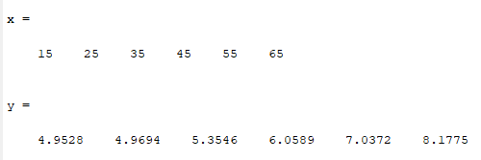

# Question 3.5

## Code

clc

clear all

v=[4000:-500:1000];

r=nthroot((3.*v)./(4*pi),3);

s= 4* pi .*r.^2 ;

disp (' V | R | S ');

disp('--------------------')

for (i=1:length(v))

disp ([num2str(v(i)), ' | ',num2str(round(r(i)*10)/10), ' | ',num2str(round(s(i)*10)/10)])

end

## Output

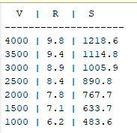

# Question 3.6

## Code

clc

clear all

mu=0.35;

theta=[5:5:35]

%a

F= 70*mu ./(mu.*sind(theta) + cosd(theta))

% b

angle=[5:0.01:35];

F1= 70*mu ./(mu.*sind(angle) + cosd(angle));

[min_F I]=min(F1);

min_F

min_at_angle=angle(I)

[max_F Ind]=max(F1);

max_F

max_at_angle=angle(Ind)

## Output

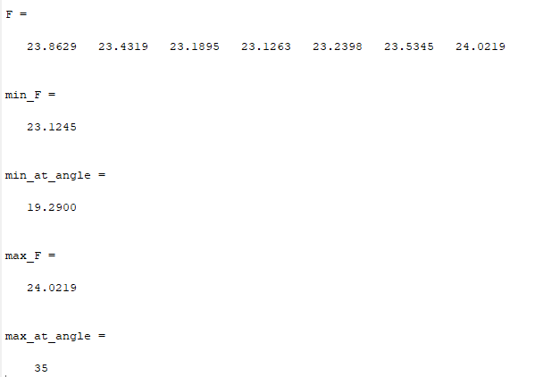

# Question 4.11

## Code

clc

clear all

h=[-500:500:10000];

p=29.921*(1 - 6.8753 *10^-6 .*h);

Tb=49.161.* log(p) + 44.932;

fprintf('Altitude | Boiling Temp\n --------------------\n')

for (i=1:length(h))

disp([num2str(h(i)), ' | ', num2str(Tb(i))])

end

## Output

